**QA ASSESMENT FOR INTERNSHIP**

**Test Case Scenario:**

1. **TS001: *User able to register using any username and password without any problem***
   * + **TC-001: Check the required fields by not filling any data**

**Script:**

**package** autoassesment;

**import** java.util.concurrent.TimeUnit;

**import** org.openqa.selenium.By;

**import** org.openqa.selenium.WebElement;

**import** org.openqa.selenium.firefox.FirefoxDriver;

**public** **class** TEST3 {

**public** **static** **void** main(String[] args) {

// **TODO** Auto-generated method stub

System.*setProperty*("webdriver.gecko.driver", "C:\\browsedrivers\\geckodriver.exe");

FirefoxDriver driver=**new** FirefoxDriver();

driver.manage().timeouts().~~implicitlyWait~~(20,TimeUnit.***SECONDS***);

driver.get("https://testing-assessment-foh15kew9-edvora.vercel.app");

driver.findElement(By.*cssSelector*(".css-d509a4")).click();

driver.findElement(By.*cssSelector*(".css-8h0nsd")).click();

driver.manage().timeouts().~~implicitlyWait~~(20,TimeUnit.***SECONDS***);

//driver.switchTo().alert().accept();

driver.manage().timeouts().~~implicitlyWait~~(1600,TimeUnit.***SECONDS***);

driver.manage().timeouts().~~implicitlyWait~~(20,TimeUnit.***SECONDS***);

}

}

**Console:**

1646919168616 geckodriver INFO Listening on 127.0.0.1:52288

1646919169467 mozrunner::runner INFO Running command: "C:\\Program Files\\Mozilla Firefox\\firefox.exe" "--marionette" "--remote-debugging-port" "51469" "-no-remote" "-profile" "C:\\Users\\talla\\AppData\\Local\\Temp\\rust_mozprofileFWjZnS"

1646919171033 Marionette INFO Marionette enabled

console.warn: SearchSettings: "get: No settings file exists, new profile?" (new NotFoundError("Could not open the file at C:\\Users\\talla\\AppData\\Local\\Temp\\rust_mozprofileFWjZnS\\search.json.mozlz4", (void 0)))

DevTools listening on ws://localhost:51469/devtools/browser/7d019cb1-cfbf-4ea8-a89e-63177c450f1f

1646919179069 Marionette INFO Listening on port 61128

1646919179644 RemoteAgent WARN TLS certificate errors will be ignored for this session

Mar 10, 2022 6:32:59 PM org.openqa.selenium.remote.ProtocolHandshake createSession

INFO: Detected dialect: W3C

**Comments:** User cannot register as per expected result.

==================================

* **TC-002:** **Check user should Register by filling all the required fields**

1. Enter username =tyui
2. Enter Password=tyui

**Script:**

**package** autoassesment;

**import** java.util.concurrent.TimeUnit;

**import** org.openqa.selenium.By;

**import** org.openqa.selenium.WebElement;

**import** org.openqa.selenium.firefox.FirefoxDriver;

**public** **class** TEST3 {

**public** **static** **void** main(String[] args) {

// **TODO** Auto-generated method stub

System.*setProperty*("webdriver.gecko.driver", "C:\\browsedrivers\\geckodriver.exe");

FirefoxDriver driver=**new** FirefoxDriver();

driver.manage().timeouts().~~implicitlyWait~~(20,TimeUnit.***SECONDS***);

driver.get("https://testing-assessment-foh15kew9-edvora.vercel.app");

driver.findElement(By.*cssSelector*(".css-d509a4")).click();

WebElement txtbx_username=

driver.findElement(By.*cssSelector*(".css-y572l6"));

txtbx_username.sendKeys("tyui");

driver.findElement(By.*xpath*("/html/body/div/div/main/div/div/div[2]/div/input" )).sendKeys("tyui");

driver.manage().timeouts().~~implicitlyWait~~(20,TimeUnit.***SECONDS***);

driver.findElement(By.*cssSelector*(".css-8h0nsd")).click();

driver.manage().timeouts().~~implicitlyWait~~(20,TimeUnit.***SECONDS***);

//driver.switchTo().alert().accept();

driver.manage().timeouts().~~implicitlyWait~~(1600,TimeUnit.***SECONDS***);

driver.manage().timeouts().~~implicitlyWait~~(20,TimeUnit.***SECONDS***);

}

}

**Console:**

1646920745526 geckodriver INFO Listening on 127.0.0.1:53041

1646920746405 mozrunner::runner INFO Running command: "C:\\Program Files\\Mozilla Firefox\\firefox.exe" "--marionette" "--remote-debugging-port" "58321" "-no-remote" "-profile" "C:\\Users\\talla\\AppData\\Local\\Temp\\rust_mozprofileXJd06V"

1646920747767 Marionette INFO Marionette enabled

console.warn: SearchSettings: "get: No settings file exists, new profile?" (new NotFoundError("Could not open the file at C:\\Users\\talla\\AppData\\Local\\Temp\\rust_mozprofileXJd06V\\search.json.mozlz4", (void 0)))

DevTools listening on ws://localhost:58321/devtools/browser/f73f084e-6f51-4c3a-957a-338c9282efd3

1646920756383 Marionette INFO Listening on port 52790

1646920757284 RemoteAgent WARN TLS certificate errors will be ignored for this session

Mar 10, 2022 6:59:17 PM org.openqa.selenium.remote.ProtocolHandshake createSession

INFO: Detected dialect: W3C

JavaScript error: https://testing-assessment-foh15kew9-edvora.vercel.app/_next/static/chunks/pages/r-4fbc1da4a6321c3f.js, line 1: TypeError: navigator.clipboard.readText is not a function

JavaScript error: https://testing-assessment-foh15kew9-edvora.vercel.app/_next/static/chunks/pages/r-4fbc1da4a6321c3f.js, line 1: TypeError: navigator.clipboard.readText is not a function

JavaScript error: https://testing-assessment-foh15kew9-edvora.vercel.app/_next/static/chunks/pages/r-4fbc1da4a6321c3f.js, line 1: TypeError: navigator.clipboard.readText is not a function

JavaScript error: https://testing-assessment-foh15kew9-edvora.vercel.app/_next/static/chunks/pages/r-4fbc1da4a6321c3f.js, line 1: TypeError: navigator.clipboard.readText is not a function

**Comments**: When I entered same password as per username then it gives a successful message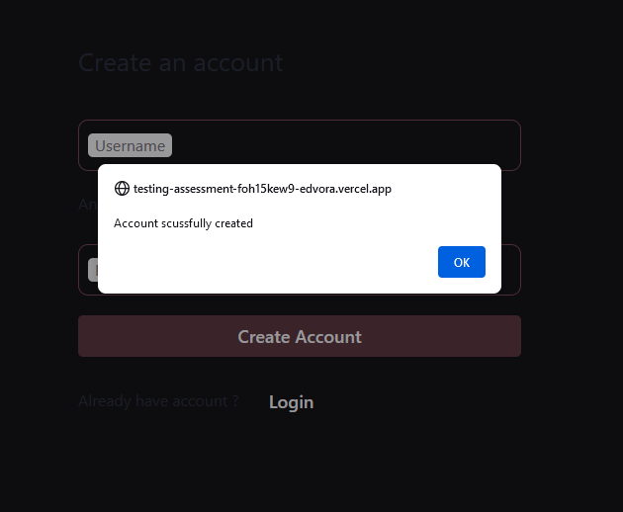

* **TC-003:** **Check the password when passing only numbers**

1. Enter username=tyui
2. Enter Password=1234

**Script:**

**package** autoassesment;

**import** java.util.concurrent.TimeUnit;

**import** org.openqa.selenium.By;

**import** org.openqa.selenium.WebElement;

**import** org.openqa.selenium.firefox.FirefoxDriver;

**public** **class** TEST3 {

**public** **static** **void** main(String[] args) {

// **TODO** Auto-generated method stub

System.*setProperty*("webdriver.gecko.driver", "C:\\browsedrivers\\geckodriver.exe");

FirefoxDriver driver=**new** FirefoxDriver();

driver.manage().timeouts().~~implicitlyWait~~(20,TimeUnit.***SECONDS***);

driver.get("https://testing-assessment-foh15kew9-edvora.vercel.app");

driver.findElement(By.*cssSelector*(".css-d509a4")).click();

WebElement txtbx_username=

driver.findElement(By.*cssSelector*(".css-y572l6"));

txtbx_username.sendKeys("tyui");

driver.findElement(By.*xpath*("/html/body/div/div/main/div/div/div[2]/div/input" )).sendKeys("1234");

driver.manage().timeouts().~~implicitlyWait~~(20,TimeUnit.***SECONDS***);

driver.findElement(By.*cssSelector*(".css-8h0nsd")).click();

driver.manage().timeouts().~~implicitlyWait~~(20,TimeUnit.***SECONDS***);

//driver.switchTo().alert().accept();

driver.manage().timeouts().~~implicitlyWait~~(1600,TimeUnit.***SECONDS***);

driver.manage().timeouts().~~implicitlyWait~~(20,TimeUnit.***SECONDS***);

}

}

**Console:**

1646921936889 geckodriver INFO Listening on 127.0.0.1:63807

1646921937817 mozrunner::runner INFO Running command: "C:\\Program Files\\Mozilla Firefox\\firefox.exe" "--marionette" "--remote-debugging-port" "54720" "-no-remote" "-profile" "C:\\Users\\talla\\AppData\\Local\\Temp\\rust_mozprofileIcAxfn"

1646921939335 Marionette INFO Marionette enabled

console.warn: SearchSettings: "get: No settings file exists, new profile?" (new NotFoundError("Could not open the file at C:\\Users\\talla\\AppData\\Local\\Temp\\rust_mozprofileIcAxfn\\search.json.mozlz4", (void 0)))

DevTools listening on ws://localhost:54720/devtools/browser/e816448d-935e-4802-8d82-ef680c3c43bb

1646921946844 Marionette INFO Listening on port 63735

1646921947311 RemoteAgent WARN TLS certificate errors will be ignored for this session

Mar 10, 2022 7:19:07 PM org.openqa.selenium.remote.ProtocolHandshake createSession

INFO: Detected dialect: W3C

JavaScript error: https://testing-assessment-foh15kew9-edvora.vercel.app/_next/static/chunks/pages/index-7d2df1b01f55f481.js, line 1: TypeError: navigator.clipboard.readText is not a function

JavaScript error: https://testing-assessment-foh15kew9-edvora.vercel.app/_next/static/chunks/pages/index-7d2df1b01f55f481.js, line 1: TypeError: navigator.clipboard.readText is not a function

JavaScript error: https://testing-assessment-foh15kew9-edvora.vercel.app/_next/static/chunks/pages/index-7d2df1b01f55f481.js, line 1: TypeError: navigator.clipboard.readText is not a function

JavaScript error: https://testing-assessment-foh15kew9-edvora.vercel.app/_next/static/chunks/pages/index-7d2df1b01f55f481.js, line 1: TypeError: navigator.clipboard.readText is not a function

**Comments:**

When I enter simple 4 digits of password. Registration is failed.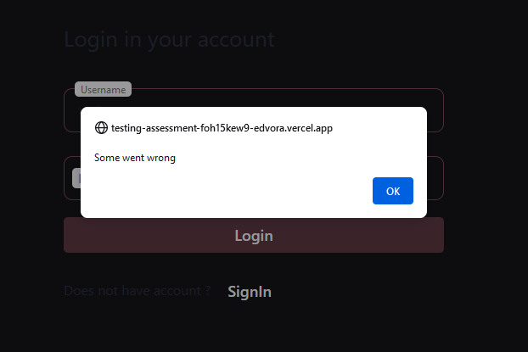

* **TC-004:** **Check the username when passing only numbers.**

1. Enter user name =1234
2. Enter password =abcd

**Script:**

**package** autoassesment;

**import** java.util.concurrent.TimeUnit;

**import** org.openqa.selenium.By;

**import** org.openqa.selenium.WebElement;

**import** org.openqa.selenium.firefox.FirefoxDriver;

**public** **class** TEST3 {

**public** **static** **void** main(String[] args) {

// **TODO** Auto-generated method stub

System.*setProperty*("webdriver.gecko.driver", "C:\\browsedrivers\\geckodriver.exe");

FirefoxDriver driver=**new** FirefoxDriver();

driver.manage().timeouts().~~implicitlyWait~~(20,TimeUnit.***SECONDS***);

driver.get("https://testing-assessment-foh15kew9-edvora.vercel.app");

driver.findElement(By.*cssSelector*(".css-d509a4")).click();

WebElement txtbx_username=

driver.findElement(By.*cssSelector*(".css-y572l6"));

txtbx_username.sendKeys("1234");

driver.findElement(By.*xpath*("/html/body/div/div/main/div/div/div[2]/div/input" )).sendKeys("abcd");

driver.manage().timeouts().~~implicitlyWait~~(20,TimeUnit.***SECONDS***);

driver.findElement(By.*cssSelector*(".css-8h0nsd")).click();

driver.manage().timeouts().~~implicitlyWait~~(20,TimeUnit.***SECONDS***);

//driver.switchTo().alert().accept();

driver.manage().timeouts().~~implicitlyWait~~(1600,TimeUnit.***SECONDS***);

driver.manage().timeouts().~~implicitlyWait~~(20,TimeUnit.***SECONDS***);

}

}

**Console:**

1646922968989 geckodriver INFO Listening on 127.0.0.1:55624

1646922969851 mozrunner::runner INFO Running command: "C:\\Program Files\\Mozilla Firefox\\firefox.exe" "--marionette" "--remote-debugging-port" "56112" "-no-remote" "-profile" "C:\\Users\\talla\\AppData\\Local\\Temp\\rust_mozprofilelgKKxz"

1646922970998 Marionette INFO Marionette enabled

console.warn: SearchSettings: "get: No settings file exists, new profile?" (new NotFoundError("Could not open the file at C:\\Users\\talla\\AppData\\Local\\Temp\\rust_mozprofilelgKKxz\\search.json.mozlz4", (void 0)))

DevTools listening on ws://localhost:56112/devtools/browser/13a4c302-bf45-4d4c-b8d9-cda54b15043d

1646922977891 Marionette INFO Listening on port 57144

1646922978382 RemoteAgent WARN TLS certificate errors will be ignored for this session

Mar 10, 2022 7:36:18 PM org.openqa.selenium.remote.ProtocolHandshake createSession

INFO: Detected dialect: W3C

JavaScript error: https://testing-assessment-foh15kew9-edvora.vercel.app/_next/static/chunks/pages/index-7d2df1b01f55f481.js, line 1: TypeError: navigator.clipboard.readText is not a function

JavaScript error: https://testing-assessment-foh15kew9-edvora.vercel.app/_next/static/chunks/pages/index-7d2df1b01f55f481.js, line 1: TypeError: navigator.clipboard.readText is not a function

JavaScript error: https://testing-assessment-foh15kew9-edvora.vercel.app/_next/static/chunks/pages/index-7d2df1b01f55f481.js, line 1: TypeError: navigator.clipboard.readText is not a function

JavaScript error: https://testing-assessment-foh15kew9-edvora.vercel.app/_next/static/chunks/pages/index-7d2df1b01f55f481.js, line 1: TypeError: navigator.clipboard.readText is not a functio

**Comments:**

When I enter simple 4 digits of username. Registration is failed.

* **TC-005:** **Check the username and password when passing alphanumeric values.**

1. Enter Username = 12ab
2. Enter Password =12ab

**Script:**

**package** autoassesment;

**import** java.util.concurrent.TimeUnit;

**import** org.openqa.selenium.By;

**import** org.openqa.selenium.WebElement;

**import** org.openqa.selenium.firefox.FirefoxDriver;

**public** **class** TEST3 {

**public** **static** **void** main(String[] args) {

// **TODO** Auto-generated method stub

System.*setProperty*("webdriver.gecko.driver", "C:\\browsedrivers\\geckodriver.exe");

FirefoxDriver driver=**new** FirefoxDriver();

driver.manage().timeouts().~~implicitlyWait~~(20,TimeUnit.***SECONDS***);

driver.get("https://testing-assessment-foh15kew9-edvora.vercel.app");

driver.findElement(By.*cssSelector*(".css-d509a4")).click();

WebElement txtbx_username=

driver.findElement(By.*cssSelector*(".css-y572l6"));

txtbx_username.sendKeys("1234");

driver.findElement(By.*xpath*("/html/body/div/div/main/div/div/div[2]/div/input" )).sendKeys("abcd");

driver.manage().timeouts().~~implicitlyWait~~(20,TimeUnit.***SECONDS***);

driver.findElement(By.*cssSelector*(".css-8h0nsd")).click();

driver.manage().timeouts().~~implicitlyWait~~(20,TimeUnit.***SECONDS***);

//driver.switchTo().alert().accept();

driver.manage().timeouts().~~implicitlyWait~~(1600,TimeUnit.***SECONDS***);

driver.manage().timeouts().~~implicitlyWait~~(20,TimeUnit.***SECONDS***);

}

}

**Console:**

1646931900007 geckodriver INFO Listening on 127.0.0.1:59990

1646931900881 mozrunner::runner INFO Running command: "C:\\Program Files\\Mozilla Firefox\\firefox.exe" "--marionette" "--remote-debugging-port" "63950" "-no-remote" "-profile" "C:\\Users\\talla\\AppData\\Local\\Temp\\rust_mozprofilegtTMSw"

1646931902506 Marionette INFO Marionette enabled

console.warn: SearchSettings: "get: No settings file exists, new profile?" (new NotFoundError("Could not open the file at C:\\Users\\talla\\AppData\\Local\\Temp\\rust_mozprofilegtTMSw\\search.json.mozlz4", (void 0)))

console.error: Region.jsm: "Error fetching region" (new Error("TIMEOUT", "resource://gre/modules/Region.jsm", 772))

console.error: Region.jsm: "Failed to fetch region" (new Error("TIMEOUT", "resource://gre/modules/Region.jsm", 419))

DevTools listening on ws://localhost:63950/devtools/browser/e1667033-de7b-4e64-9826-d5c6d556c374

1646931913186 Marionette INFO Listening on port 56509

1646931915263 RemoteAgent WARN TLS certificate errors will be ignored for this session

Mar 10, 2022 10:05:15 PM org.openqa.selenium.remote.ProtocolHandshake createSession

INFO: Detected dialect: W3C

JavaScript error: https://testing-assessment-foh15kew9-edvora.vercel.app/_next/static/chunks/pages/index-7d2df1b01f55f481.js, line 1: TypeError: navigator.clipboard.readText is not a function

JavaScript error: https://testing-assessment-foh15kew9-edvora.vercel.app/_next/static/chunks/pages/index-7d2df1b01f55f481.js, line 1: TypeError: navigator.clipboard.readText is not a function

JavaScript error: https://testing-assessment-foh15kew9-edvora.vercel.app/_next/static/chunks/pages/index-7d2df1b01f55f481.js, line 1: TypeError: navigator.clipboard.readText is not a function

JavaScript error: https://testing-assessment-foh15kew9-edvora.vercel.app/_next/static/chunks/pages/index-7d2df1b01f55f481.js, line 1: TypeError: navigator.clipboard.readText is not a function

**Comments:**

Registration not done properly.

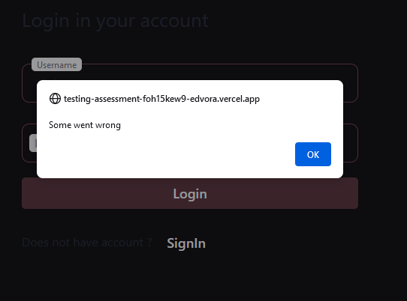

1. ***TS002 -User able to login using username and password created***
   * + **TC-001: Check the required fields by filling valid data**

**Script:**

**package** autoassesment;

**import** java.util.concurrent.TimeUnit;

**import** org.openqa.selenium.By;

**import** org.openqa.selenium.WebElement;

**import** org.openqa.selenium.chrome.ChromeDriver;

**import** org.openqa.selenium.edge.EdgeDriver;

**import** org.openqa.selenium.firefox.FirefoxDriver;

**public** **class** TEST3 {

**public** **static** **void** main(String[] args) {

// **TODO** Auto-generated method stub

System.*setProperty*("webdriver.gecko.driver", "C:\\browsedrivers\\geckodriver.exe");

FirefoxDriver driver=**new** FirefoxDriver();

driver.manage().timeouts().~~implicitlyWait~~(20,TimeUnit.***SECONDS***);

//driver.get("http://www.google.com");

driver.get("https://testing-assessment-foh15kew9-edvora.vercel.app");

WebElement txtbx_username=

driver.findElement(By.*cssSelector*(".css-y572l6"));

//driver.manage().timeouts().implicitlyWait(20,TimeUnit.SECONDS);

txtbx_username.sendKeys("tyui");

//driver.manage().timeouts().implicitlyWait(20,TimeUnit.SECONDS);

//driver.manage().timeouts().implicitlyWait(20,TimeUnit.SECONDS);

driver.findElement(By.*xpath*("/html/body/div/div/main/div/div/div[2]/div/input")).sendKeys("tyui");

//driver.manage().timeouts().implicitlyWait(20,TimeUnit.SECONDS);

driver.manage().timeouts().~~implicitlyWait~~(70,TimeUnit.***SECONDS***);

driver.findElement(By.*cssSelector*(".css-8h0nsd")).click();

//driver.manage().timeouts().implicitlyWait(120,TimeUnit.SECONDS);

//driver.manage().timeouts().implicitlyWait(20,TimeUnit.SECONDS);

//driver.switchTo().alert().accept();

//driver.manage().timeouts().implicitlyWait(1600,TimeUnit.SECONDS);

//driver.manage().timeouts().implicitlyWait(20,TimeUnit.SECONDS);

}

}

**Console:**

1646935886957 geckodriver INFO Listening on 127.0.0.1:52779

1646935887967 mozrunner::runner INFO Running command: "C:\\Program Files\\Mozilla Firefox\\firefox.exe" "--marionette" "--remote-debugging-port" "59362" "-no-remote" "-profile" "C:\\Users\\talla\\AppData\\Local\\Temp\\rust_mozprofilemAV9TR"

1646935889572 Marionette INFO Marionette enabled

console.warn: SearchSettings: "get: No settings file exists, new profile?" (new NotFoundError("Could not open the file at C:\\Users\\talla\\AppData\\Local\\Temp\\rust_mozprofilemAV9TR\\search.json.mozlz4", (void 0)))

DevTools listening on ws://localhost:59362/devtools/browser/1d9cdcb8-6938-460e-bd91-fbdbed8cda32

1646935898344 Marionette INFO Listening on port 51464

1646935898763 RemoteAgent WARN TLS certificate errors will be ignored for this session

Mar 10, 2022 11:11:39 PM org.openqa.selenium.remote.ProtocolHandshake createSession

INFO: Detected dialect: W3C

JavaScript error: https://testing-assessment-foh15kew9-edvora.vercel.app/_next/static/chunks/pages/index-7d2df1b01f55f481.js, line 1: TypeError: navigator.clipboard.readText is not a function

JavaScript error: https://testing-assessment-foh15kew9-edvora.vercel.app/_next/static/chunks/pages/index-7d2df1b01f55f481.js, line 1: TypeError: navigator.clipboard.readText is not a function

JavaScript error: https://testing-assessment-foh15kew9-edvora.vercel.app/_next/static/chunks/pages/index-7d2df1b01f55f481.js, line 1: TypeError: navigator.clipboard.readText is not a function

JavaScript error: https://testing-assessment-foh15kew9-edvora.vercel.app/_next/static/chunks/pages/index-7d2df1b01f55f481.js, line 1: TypeError: navigator.clipboard.readText is not a function

**Comments:** response time is too slow regarding the message of server side resources failure

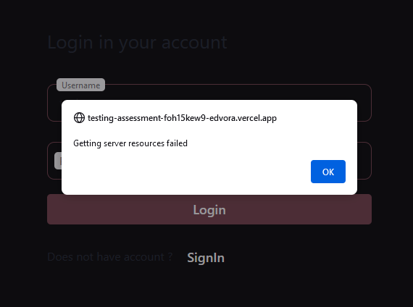

**Summery:**

**Behavior on Edge and Firefox**

**(registration)**

* For my automation purpose I use edge and Firefox browsers and I collect the information that registration is not properly done .some times msg shown successful and some times somethings wrong msg is arrived
* We cannot add a username more then 5 letters. Also length of password is also 5.

**(Login page)**

* Login is not possible through valid username and password
* Also sometimes password textbox is not working properly and same condition of login button
* Response of server resources are failed arrived too late.

**Behavior on Chrome Browser**

* Unfortunately, my chrome driver for selenium is not working properly that’s why I cannot able to test script on chrome but through manual testing I noticed that.
* Registration is smoothly done when we add credentials of length 5. every type of numeric ,alphanumeric and alphabets combination can registered successfully .
* There are no such validations that username must start with alphabets.
* Also, when successful popup is arrived and we click ok then the flow disturbs and instead of going to login page it redirect to the settings page where we edit further information.
* Login functionality is not working here too.
* Also when we redirected to settings page which is also wrong move but any how we are on it and when we edit some info and press the save button application redirect user to some new unsecured website(manike.com) .

I try my best to find some of that issues as I also saw my email too late that’s why I cannot write bug report.Thankyou so much for this assessment that you guys gave me.

**BUG REPORT**

**Test case number TC-001**

**Bug number - 001**

**Bug title - User unable to login**

**Steps to reproduce the bug**

**1)go to the URL**

**2)input all the fields.**

**3)click on "login"**

**4)note that there is an error.**

**Bug severity: High**

**Bug priority : High**

**Expected result : User should be able to login**

**Actual result: User unable to login when the username field does not have numerical numbers as input.**